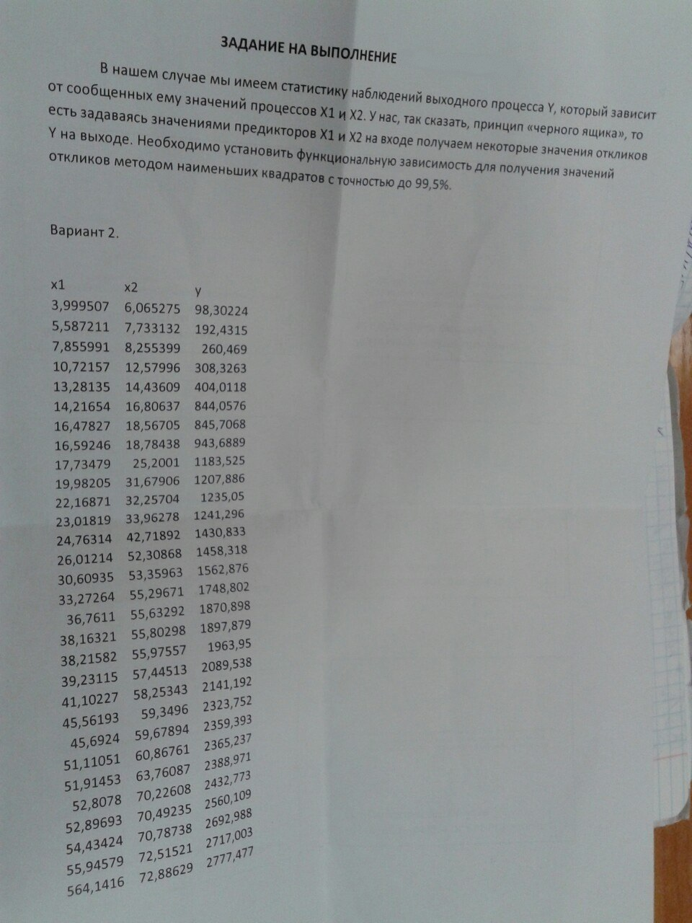

***ПРИМЕР РЕШЕНИЯ:***

|  |  |  |
| --- | --- | --- |
| X1 | X2 | Y |
| 6,33075 | 8,007934 | 55,98038 |
| 7,300799 | 9,06198 | 174,5599 |
| 8,101766 | 9,100276 | 284,0713 |
| 9,850802 | 10,04906 | 417,9699 |
| 11,87433 | 12,59465 | 553,1396 |
| 15,6004 | 15,82344 | 693,2214 |
| 16,53965 | 21,745 | 1089,007 |
| 18,75473 | 25,4907 | 1101,933 |
| 19,62071 | 26,70465 | 1347,612 |
| 25,42131 | 27,4087 | 1509,382 |
| 25,47831 | 30,20048 | 1665,97 |
| 25,62821 | 34,06406 | 1710,574 |
| 25,85426 | 34,3787 | 1764,62 |
| 29,58929 | 36,03376 | 1781,038 |
| 30,71104 | 36,69804 | 1792,508 |
| 31,02713 | 39,47959 | 1857,336 |
| 33,92647 | 44,94784 | 1913,989 |
| 36,3128 | 45,45878 | 1921,808 |
| 39,96153 | 47,41768 | 1990,972 |
| 40,11358 | 48,73738 | 2078,562 |
| 41,44394 | 49,66386 | 2222,658 |
| 45,84192 | 51,54933 | 2247,068 |
| 46,34949 | 55,22731 | 2312,632 |
| 47,66596 | 55,60985 | 2363,418 |
| 50,22039 | 57,21137 | 2367,139 |
| 51,29373 | 59,38141 | 2390,152 |
| 52,85215 | 60,0023 | 2745,068 |
| 54,58466 | 69,29335 | 2840,661 |
| 54,70137 | 72,07075 | 3039,878 |
| 2807,823 | 75,35904 | 3089,511 |

1. ***Нахождение оценки коэффициента корреляции:***

Т.к. 

То сначала найдем и :

n=30, , ,, , .

|  |  |  |  |  |  |  |  |
| --- | --- | --- | --- | --- | --- | --- | --- |
| u1 | u2 | u3 | u1^2 | u2^2 | u3^2 | u1u3 | u2u3 |
| -116669 | -30992 | -1654020 | 13611713896 | 960508155 | 2735780903345 | 192973228551 | 51261485228 |
| -115699 | -29938 | -1535440 | 13386305112 | 896285042 | 2357576300688 | 177649192753 | 45968036423 |
| -114898 | -29900 | -1425929 | 13201604176 | 893993495 | 2033272657484 | 163836689440 | 42634874574 |
| -113149 | -28951 | -1292030 | 12802741008 | 838156927 | 1669341779306 | 146192169607 | 37405485903 |
| -111126 | -26405 | -1156860 | 12348914533 | 697242509 | 1338325985088 | 128556887046 | 30547303763 |
| -107400 | -23177 | -1016779 | 11534674080 | 537152933 | 1033838721418 | 109201614929 | 23565430230 |
| -106460 | -17255 | -620993 | 11333806122 | 297735025 | 385632306049 | 66111132128 | 10715234215 |
| -104245 | -13509 | -608067 | 10867076317 | 182501186 | 369745476489 | 63388108593 | 8214559523 |
| -103379 | -12295 | -362388 | 10687277601 | 151175632 | 131325062544 | 37463414145 | 4455687296 |
| -97579 | -11591 | -200618 | 9521600742 | 134358236 | 40247581924 | 19576041630 | 2325423423 |
| -97522 | -8800 | -44030 | 9510480020 | 77431552 | 1938640900 | 4293880011 | 387442865,6 |
| -97372 | -4936 | 574 | 9481265488 | 24363504 | 329476 | -55891407 | -2833229,56 |
| -97146 | -4621 | 54620 | 9437294800 | 21356414 | 2983344400 | -5306100319 | -252415406 |
| -93411 | -2966 | 71038 | 8725560743 | 8798580 | 5046397444 | -6635710017 | -210715757,1 |
| -92289 | -2302 | 82508 | 8517252138 | 5299020 | 6807570064 | -7614577512 | -189930115,7 |
| -91973 | 480 | 147336 | 8459008816 | 230007 | 21707896896 | -13550914774 | 70660872,24 |
| -89074 | 5948 | 203989 | 7934093747 | 35376801 | 41611512121 | -18170020311 | 1213293934 |
| -86687 | 6459 | 211808 | 7514670644 | 41715839 | 44862628864 | -18361042458 | 1368021274 |
| -83038 | 8418 | 280972 | 6895387500 | 70857337 | 78945264784 | -23331484993 | 2365132385 |
| -82886 | 9737 | 368562 | 6870158620 | 94816569 | 135837947844 | -30548784728 | 3588828248 |
| -81556 | 10664 | 512658 | 6651390923 | 113717910 | 262818224964 | -41810366607 | 5466913140 |
| -77158 | 12549 | 537068 | 5953369309 | 157485683 | 288442036624 | -41439135709 | 6739843564 |
| -76651 | 16227 | 602632 | 5875300683 | 263325590 | 363165327424 | -46192050142 | 9779096280 |
| -75334 | 16610 | 653418 | 5675217583 | 275887117 | 426955082724 | -49224617749 | 10853174967 |
| -72780 | 18211 | 657139 | 5296871632 | 331653997 | 431831665321 | -47826320136 | 11967401470 |
| -71706 | 20381 | 680152 | 5141789157 | 415401874 | 462606743104 | -48771162953 | 13862456774 |
| -70148 | 21002 | 1035068 | 4920720860 | 441096605 | 1071365764624 | -72607794804 | 21738808656 |
| -68415 | 30293 | 1130661 | 4680658747 | 917687054 | 1278394296921 | -77354556740 | 34251509404 |
| -68299 | 33071 | 1329878 | 4664702860 | 1093674506 | 1768575494884 | -90828845467 | 43980062869 |
| 2684823 | 36359 | 1379511 | 7208274541329 | 1321979790 | 1903050599121 | 3703742861553 | 50157695629 |
| Сумма |  |  |  |  |  |  |  |
| 20774 | -1229 | 22438 | 7459775449186 | 11301264887 | 20692033542839 | 4173355843559 | 474227968403 |

, , 

,

,

.

















Тогда коэффициент корреляции:

;

.

***3. Нахождение линейной и квадратичной регрессий:***

* Линейная регрессия





 (1)

 (2)

 (3)

|  |  |  |  |  |
| --- | --- | --- | --- | --- |
| x1^2 | x2^2 | x1x2 | x1y | x2y |
| 40,0784 | 64,12701 | 50,69623 | 354,3978 | 448,2872 |
| 53,30167 | 82,11948 | 66,15969 | 1274,427 | 1581,858 |
| 65,63861 | 82,81502 | 73,72831 | 2301,479 | 2585,127 |
| 97,0383 | 100,9836 | 98,9913 | 4117,339 | 4200,205 |
| 140,9997 | 158,6252 | 149,553 | 6568,162 | 6966,6 |
| 243,3725 | 250,3813 | 246,852 | 10814,53 | 10969,15 |
| 273,56 | 472,845 | 359,6547 | 18011,79 | 23680,46 |
| 351,7399 | 649,7758 | 478,0712 | 20666,46 | 28089,04 |
| 384,9723 | 713,1383 | 523,9642 | 26441,1 | 35987,51 |
| 646,243 | 751,2368 | 696,7651 | 38370,47 | 41370,2 |
| 649,1443 | 912,069 | 769,4572 | 42446,1 | 50313,09 |
| 656,8051 | 1160,36 | 873,0009 | 43838,95 | 58269,1 |
| 668,4428 | 1181,895 | 888,8358 | 45622,94 | 60665,34 |
| 875,5261 | 1298,432 | 1066,213 | 52699,65 | 64177,5 |
| 943,168 | 1346,746 | 1127,035 | 55049,78 | 65781,53 |
| 962,6828 | 1558,638 | 1224,938 | 57627,81 | 73326,86 |
| 1151,005 | 2020,308 | 1524,922 | 64934,89 | 86029,67 |
| 1318,619 | 2066,501 | 1650,736 | 69786,23 | 87363,05 |
| 1596,924 | 2248,436 | 1894,883 | 79562,29 | 94407,27 |
| 1609,099 | 2375,332 | 1955,031 | 83378,56 | 101303,7 |
| 1717,6 | 2466,499 | 2058,266 | 92115,7 | 110385,8 |
| 2101,482 | 2657,333 | 2363,12 | 103009,9 | 115834,8 |
| 2148,275 | 3050,056 | 2559,758 | 107189,3 | 127720,4 |
| 2272,044 | 3092,455 | 2650,697 | 112654,6 | 131429,3 |
| 2522,088 | 3273,141 | 2873,177 | 118878,6 | 135427,3 |
| 2631,047 | 3526,152 | 3045,894 | 122599,8 | 141930,6 |
| 2793,35 | 3600,276 | 3171,251 | 145082,7 | 164710,4 |
| 2979,485 | 4801,568 | 3782,354 | 155056,5 | 196838,9 |
| 2992,24 | 5194,193 | 3942,369 | 166285,5 | 219086,3 |
| 7883870 | 5678,985 | 211594,8 | 8674800 | 232822,6 |
| Сумма |  |  |  |  |
| 7918756 | 56835,42 | 253761,2 | 10521540 | 2473702 |

Методом обратной матрицы:

Корни уравнения:



Тогда: 

* Квадратичная регрессия:





 (1)

 (2)

(3)

 (4)

 (5)

 (6)

Из (1) (2) (3) (4) (5) и (6) методом обратной матрицы находим коэффициенты:





***4. Проверка адекватности математических моделей.***

* Линейная регрессия:





|  |  |  |  |  |  |
| --- | --- | --- | --- | --- | --- |
| x1 | x2 | y | yлин | Δy | Δy2 |
| 6,331 | 8,008 | 55,980 | 400,361654 | -344,381 | 118598,462 |
| 7,301 | 9,062 | 174,560 | 445,179795 | -270,620 | 73235,128 |
| 8,102 | 9,100 | 284,071 | 446,759139 | -162,688 | 26467,333 |
| 9,851 | 10,049 | 417,970 | 487,045474 | -69,076 | 4771,435 |
| 11,874 | 12,595 | 553,140 | 595,304645 | -42,165 | 1777,891 |
| 15,600 | 15,823 | 693,221 | 732,544826 | -39,323 | 1546,332 |
| 16,540 | 21,745 | 1089,007 | 984,618817 | 104,388 | 10896,893 |
| 18,755 | 25,491 | 1101,933 | 1143,96521 | -42,032 | 1766,707 |
| 19,621 | 26,705 | 1347,612 | 1195,59857 | 152,013 | 23108,084 |
| 25,421 | 27,409 | 1509,382 | 1225,20507 | 284,177 | 80756,526 |
| 25,478 | 30,200 | 1665,970 | 1344,07263 | 321,897 | 103617,919 |
| 25,628 | 34,064 | 1710,574 | 1508,57041 | 202,004 | 40805,452 |
| 25,854 | 34,379 | 1764,620 | 1521,95299 | 242,667 | 58887,275 |
| 29,589 | 36,034 | 1781,038 | 1592,18475 | 188,853 | 35665,549 |
| 30,711 | 36,698 | 1792,508 | 1620,39734 | 172,111 | 29622,080 |
| 31,027 | 39,480 | 1857,336 | 1738,81273 | 118,523 | 14047,766 |
| 33,926 | 44,948 | 1913,989 | 1971,45979 | -57,471 | 3302,891 |
| 36,313 | 45,459 | 1921,808 | 1993,06237 | -71,254 | 5077,186 |
| 39,962 | 47,418 | 1990,972 | 2076,23686 | -85,265 | 7270,096 |
| 40,114 | 48,737 | 2078,562 | 2132,41863 | -53,857 | 2900,537 |
| 41,444 | 49,664 | 2222,658 | 2171,78208 | 50,876 | 2588,359 |
| 45,842 | 51,549 | 2247,068 | 2251,78204 | -4,714 | 22,222 |
| 46,349 | 55,227 | 2312,632 | 2408,35427 | -95,722 | 9162,752 |
| 47,666 | 55,610 | 2363,418 | 2424,55818 | -61,140 | 3738,122 |
| 50,220 | 57,211 | 2367,139 | 2492,58582 | -125,447 | 15736,904 |
| 51,294 | 59,381 | 2390,152 | 2584,91526 | -194,763 | 37932,727 |
| 52,852 | 60,002 | 2745,068 | 2611,25239 | 133,816 | 17906,616 |
| 54,585 | 69,293 | 2840,661 | 3006,74513 | -166,084 | 27583,939 |
| 54,701 | 72,071 | 3039,878 | 3124,99658 | -85,119 | 7245,172 |
| 2807,823 | 75,359 | 3089,511 | 3088,80889 | 0,702 | 0,493 |
|  |  |  |  |  |  |
|  |  |  |  |  | 766039 |









Т.к. , то гипотеза  принимается, т.е. модель адекватна.

* Квадратичная регрессия



|  |  |  |  |  |  |
| --- | --- | --- | --- | --- | --- |
| x1 | x2 | y | yкв | Δy | Δy2 |
| 6,331 | 8,008 | 55,980 | 404,199821 | -348,219 | 121256,779 |
| 7,301 | 9,062 | 174,560 | 441,153381 | -266,593 | 71072,084 |
| 8,102 | 9,100 | 284,071 | 360,647567 | -76,576 | 5863,925 |
| 9,851 | 10,049 | 417,970 | 306,786069 | 111,184 | 12361,844 |
| 11,874 | 12,595 | 553,140 | 446,274348 | 106,865 | 11420,182 |
| 15,600 | 15,823 | 693,221 | 525,727773 | 167,494 | 28054,115 |
| 16,540 | 21,745 | 1089,007 | 1079,93329 | 9,074 | 82,332 |
| 18,755 | 25,491 | 1101,933 | 1263,98939 | -162,056 | 26262,273 |
| 19,621 | 26,705 | 1347,612 | 1312,07647 | 35,536 | 1262,774 |
| 25,421 | 27,409 | 1509,382 | 1147,03104 | 362,351 | 131298,217 |
| 25,478 | 30,200 | 1665,970 | 1357,01388 | 308,956 | 95453,882 |
| 25,628 | 34,064 | 1710,574 | 1564,53178 | 146,042 | 21328,331 |
| 25,854 | 34,379 | 1764,620 | 1575,3696 | 189,250 | 35815,714 |
| 29,589 | 36,034 | 1781,038 | 1623,56599 | 157,472 | 24797,435 |
| 30,711 | 36,698 | 1792,508 | 1651,34074 | 141,167 | 19928,195 |
| 31,027 | 39,480 | 1857,336 | 1753,81123 | 103,525 | 10717,377 |
| 33,926 | 44,948 | 1913,989 | 1899,88273 | 14,106 | 198,987 |
| 36,313 | 45,459 | 1921,808 | 1980,9037 | -59,096 | 3492,302 |
| 39,962 | 47,418 | 1990,972 | 2136,27539 | -145,303 | 21113,074 |
| 40,114 | 48,737 | 2078,562 | 2151,93664 | -73,375 | 5383,837 |
| 41,444 | 49,664 | 2222,658 | 2217,71173 | 4,946 | 24,466 |
| 45,842 | 51,549 | 2247,068 | 2459,25259 | -212,185 | 45022,299 |
| 46,349 | 55,227 | 2312,632 | 2476,5131 | -163,881 | 26857,015 |
| 47,666 | 55,610 | 2363,418 | 2565,51028 | -202,092 | 40841,291 |
| 50,220 | 57,211 | 2367,139 | 2737,57787 | -370,439 | 137224,959 |
| 51,294 | 59,381 | 2390,152 | 2787,29397 | -397,142 | 157721,741 |
| 52,852 | 60,002 | 2745,068 | 2910,73836 | -165,670 | 27446,668 |
| 54,585 | 69,293 | 2840,661 | 2651,16001 | 189,501 | 35910,624 |
| 54,701 | 72,071 | 3039,878 | 2433,36719 | 606,511 | 367855,359 |
| 2807,823 | 75,359 | 3089,511 | 4315,7068 | -1226,196 | 1503556,150 |
|  |  |  |  |  |  |
|  |  |  |  |  | 2989624 |







Т.к. , то гипотеза отвергается, а гипотеза  принимается, т.е. модель неадекватна.

* Вывод: выбираем линейную регрессию, т.к. она адекватна.